# Kenton 5-pc. Dining Set

Description $1,149.95

The best part about this Kenton 5-piece dining set may be its ability to mix and match styles so well! Its dark walnut and ebony finishes serve up a casual two-toned look, plus its smaller scaling makes it a smart choice for an eat-in kitchen or breakfast nook. But this dining set also features more formal design elements, like a gorgeous pedestal table base and keyhole chair backs. And if you're space conscious, you'll appreciate the table's self-storing butterfly leaf—it provides extra table space when you need it and can easily be stowed out of sight when you don't!

Product Details

* Color Ebony/Dark Walnut
* Style Farmhouse
* Finish Painted, Walnut Dark
* Dining Height Standard
* Pieces in Set 5
* Table Base Type Pedestal
* Table Shape Oval
* Leaf Type Butterfly
* Seating Type Dining
* Weight 0 lbs
* Care Dust with a soft, dry cloth. All spills should be cleaned up immediately.
* 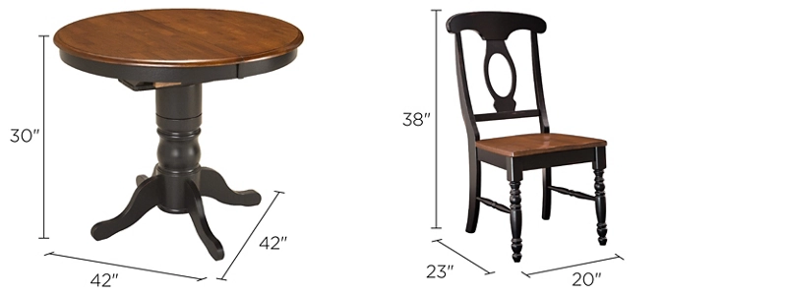Vendor Bellanest